### **1. BMW India:**

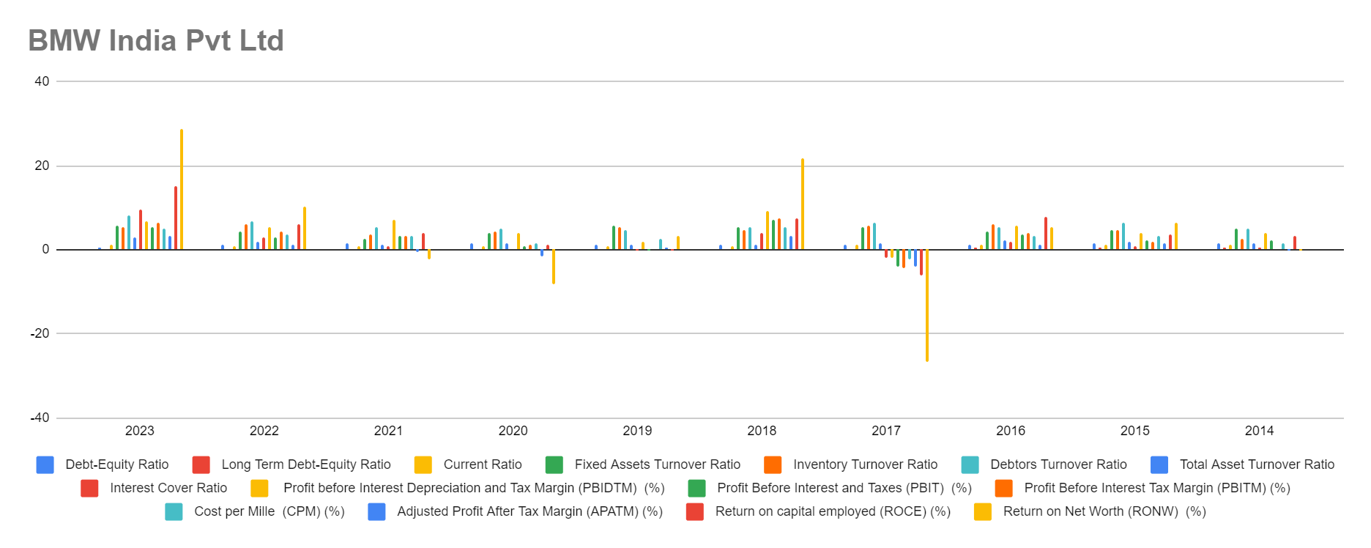

1. Debt-Equity Ratio (DER): Generally low, indicating a conservative capital structure.
2. Long Term Debt-Equity Ratio: Similar trend to DER, suggesting prudent long-term debt management.
3. Current Ratio: Fluctuates but generally above 1, indicating satisfactory liquidity levels.
4. Fixed Assets Turnover Ratio: Generally high, indicating efficient utilization of fixed assets.
5. Inventory Turnover Ratio: Generally high, suggesting efficient management of inventory.
6. Debtors Turnover Ratio: Generally high, indicating effective receivables management.
7. Total Asset Turnover Ratio: Generally high, indicating efficient asset utilization.
8. Interest Cover Ratio: Shows fluctuations but generally positive, indicating the ability to cover interest expenses with earnings.
9. Profitability Ratios: Generally positive, indicating satisfactory profitability levels.

### **2. Tata Motors India:**

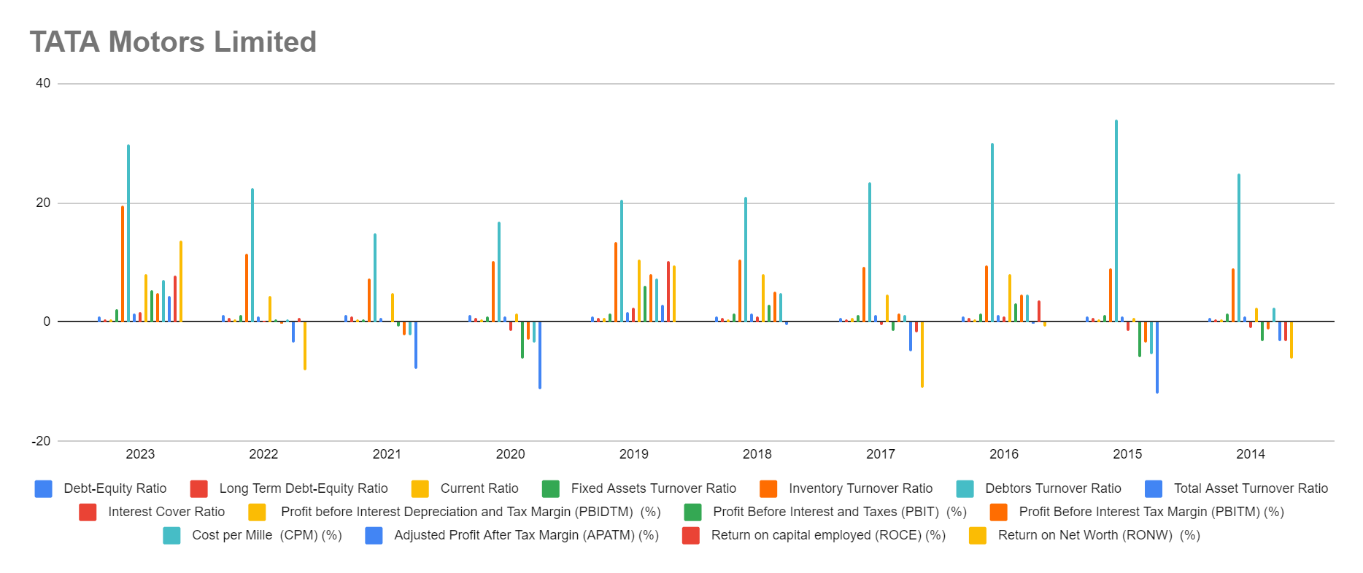

1. Debt-Equity Ratio (DER): Shows a fluctuating trend, but generally maintains a moderate level, indicating a balanced capital structure.
2. Long Term Debt-Equity Ratio: Similar to DER, fluctuates but remains within reasonable limits, suggesting manageable long-term debt levels.
3. Current Ratio: Shows fluctuations but generally remains below 1, indicating potential liquidity challenges in some years.
4. Fixed Assets Turnover Ratio: Fluctuates, indicating varying efficiency in utilizing fixed assets to generate sales.
5. Inventory Turnover Ratio: Fluctuates but generally suggests efficient management of inventory.
6. Debtors Turnover Ratio: Fluctuates but indicates the company's ability to collect receivables efficiently.
7. Total Asset Turnover Ratio: Fluctuates, suggesting varying efficiency in asset utilization.
8. Interest Cover Ratio: Shows fluctuations, with some years indicating negative values, suggesting potential financial strain.
9. Profitability Ratios: Show fluctuations, with some years indicating negative profitability, which is concerning.

### **3. Skoda Volkswagen India Ltd:**

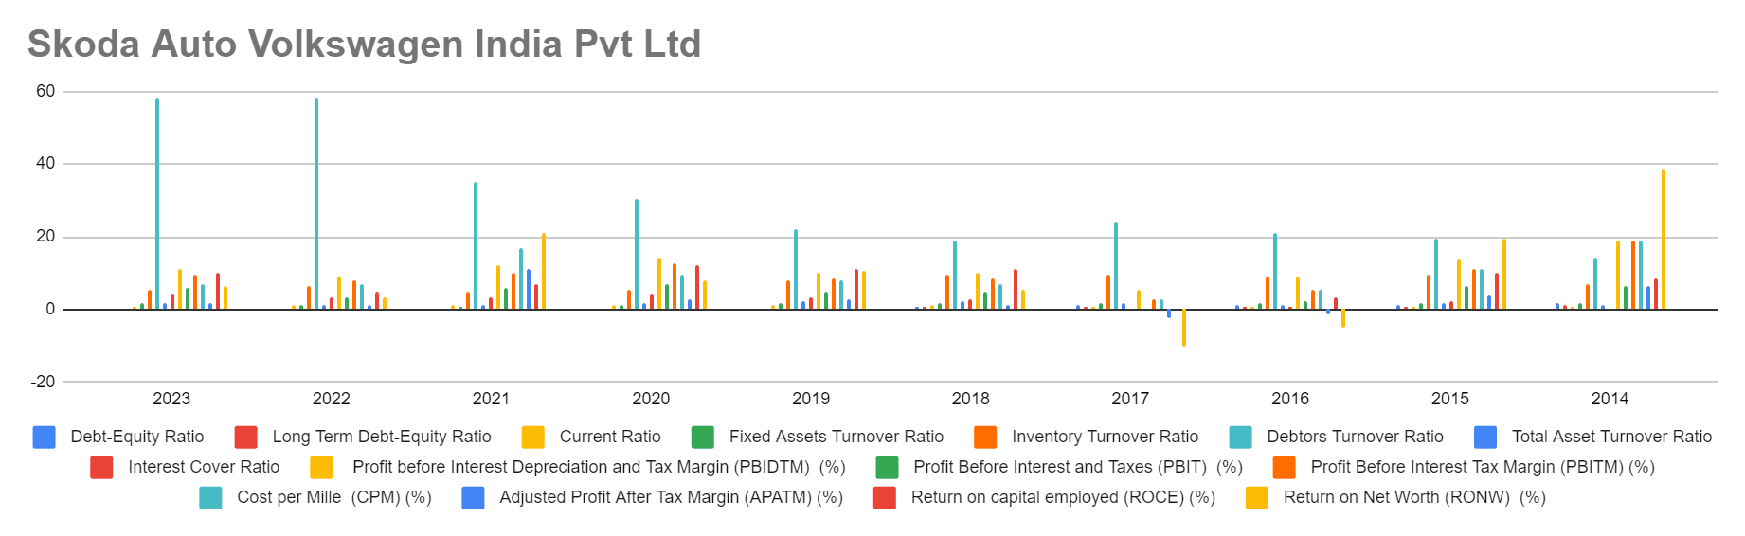

1. Debt-Equity Ratio (DER): Generally low, except for a spike in 2014, indicating a relatively conservative capital structure.
2. Long Term Debt-Equity Ratio: Similar trend to DER, suggesting prudent long-term debt management.
3. Current Ratio: Fluctuates but generally above 1, indicating satisfactory liquidity levels.
4. Fixed Assets Turnover Ratio: Generally high, indicating efficient utilization of fixed assets.
5. Inventory Turnover Ratio: Generally high, suggesting efficient management of inventory.
6. Debtors Turnover Ratio: Generally high, indicating effective receivables management.
7. Total Asset Turnover Ratio: Generally high, indicating efficient asset utilization.
8. Interest Cover Ratio: Shows fluctuations but generally positive, indicating the ability to cover interest expenses with earnings.
9. Profitability Ratios: Generally positive, indicating satisfactory profitability levels.

### **4. Renault India Pvt Limited:**

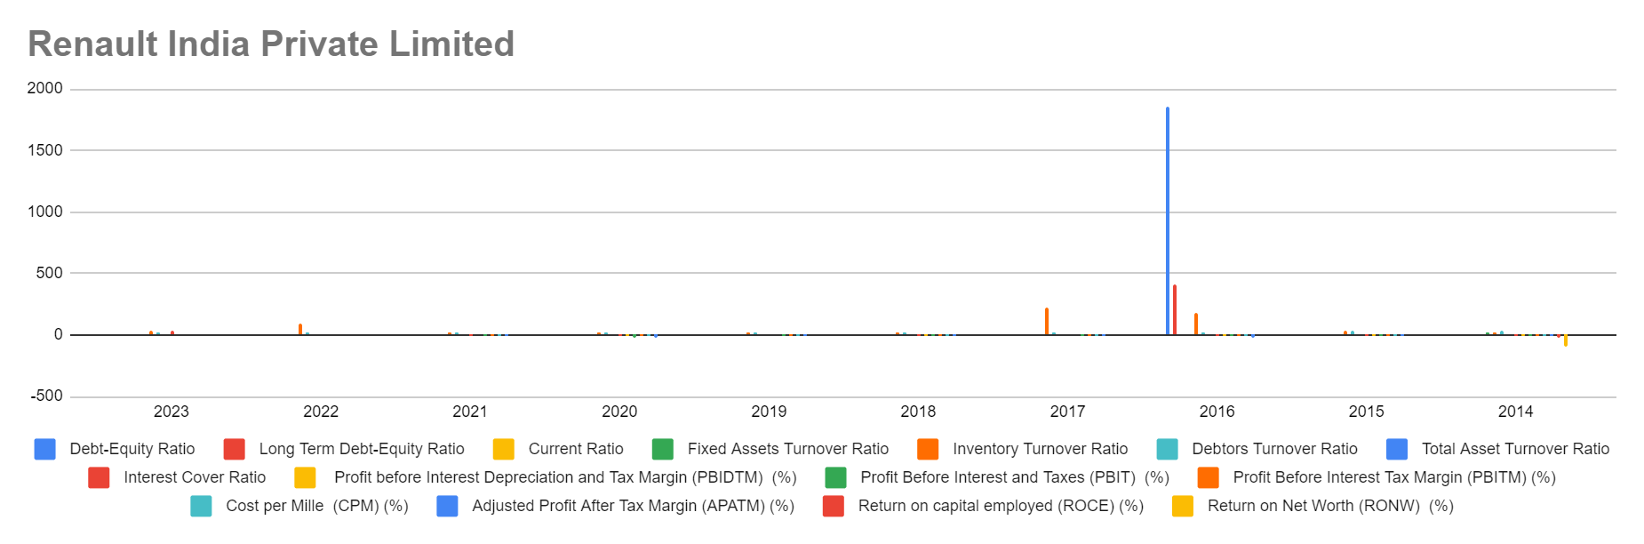

1. Debt-Equity Ratio (DER): Shows fluctuations but generally maintains a moderate level.
2. Long Term Debt-Equity Ratio: Similar trend to DER, suggesting a balanced approach to long-term debt.
3. Current Ratio: Fluctuates but generally above 1, indicating satisfactory liquidity levels.
4. Fixed Assets Turnover Ratio: Fluctuates, indicating varying efficiency in utilizing fixed assets.
5. Inventory Turnover Ratio: Generally high, suggesting efficient inventory management.
6. Debtors Turnover Ratio: Generally high, indicating effective receivables management.
7. Total Asset Turnover Ratio: Fluctuates, suggesting varying efficiency in asset utilization.
8. Interest Cover Ratio: Shows fluctuations, with some years indicating negative values, suggesting potential financial strain.
9. Profitability Ratios: Fluctuate, with some years indicating negative profitability, which is concerning.

### **5. Maruti Suzuki India Ltd:**

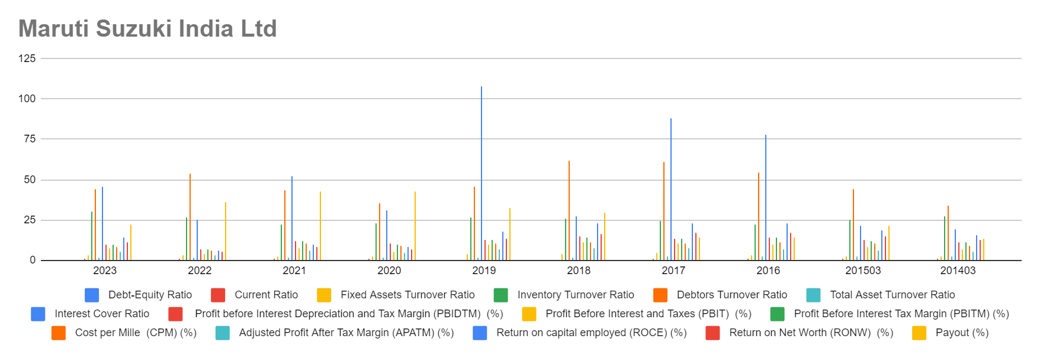

1. Debt-Equity Ratio (DER): Generally low, indicating a conservative capital structure.
2. Long Term Debt-Equity Ratio: Similar trend to DER, suggesting prudent long-term debt management.
3. Current Ratio: Fluctuates but generally above 1, indicating satisfactory liquidity levels.
4. Fixed Assets Turnover Ratio: Generally high, indicating efficient utilization of fixed assets.
5. Inventory Turnover Ratio: Generally high, suggesting efficient management of inventory.
6. Debtors Turnover Ratio: Generally high, indicating effective receivables management.
7. Total Asset Turnover Ratio: Generally high, indicating efficient asset utilization.
8. Interest Cover Ratio: Generally positive, indicating the ability to cover interest expenses with earnings.
9. Profitability Ratios: Generally positive, indicating satisfactory profitability levels.

### **6. Mahindra and Mahindra:**

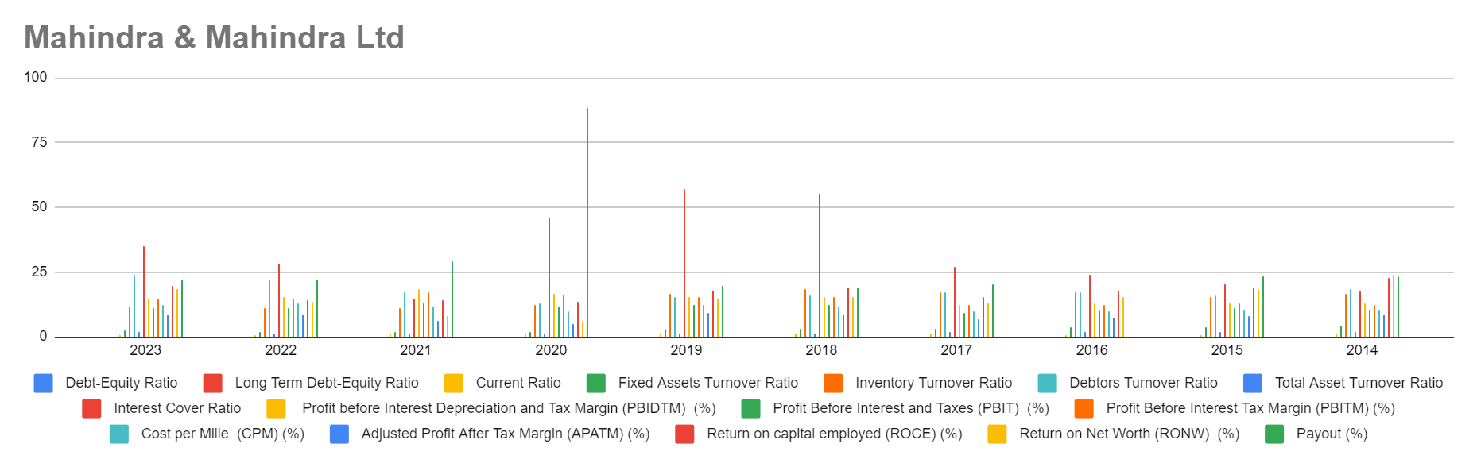

1. Debt-Equity Ratio (DER): Shows fluctuations but generally maintains a moderate level.
2. Long Term Debt-Equity Ratio: Similar trend to DER, suggesting a balanced approach to long-term debt.
3. Current Ratio: Fluctuates but generally above 1, indicating satisfactory liquidity levels.
4. Fixed Assets Turnover Ratio: Generally high, indicating efficient utilization of fixed assets.
5. Inventory Turnover Ratio: Generally high, suggesting efficient management of inventory.
6. Debtors Turnover Ratio: Generally high, indicating effective receivables management.
7. Total Asset Turnover Ratio: Generally high, indicating efficient asset utilization.
8. Interest Cover Ratio: Shows fluctuations but generally positive, indicating the ability to cover interest expenses with earnings.
9. Profitability Ratios: Generally positive, indicating satisfactory profitability levels.

### **7. Hyundai India:**

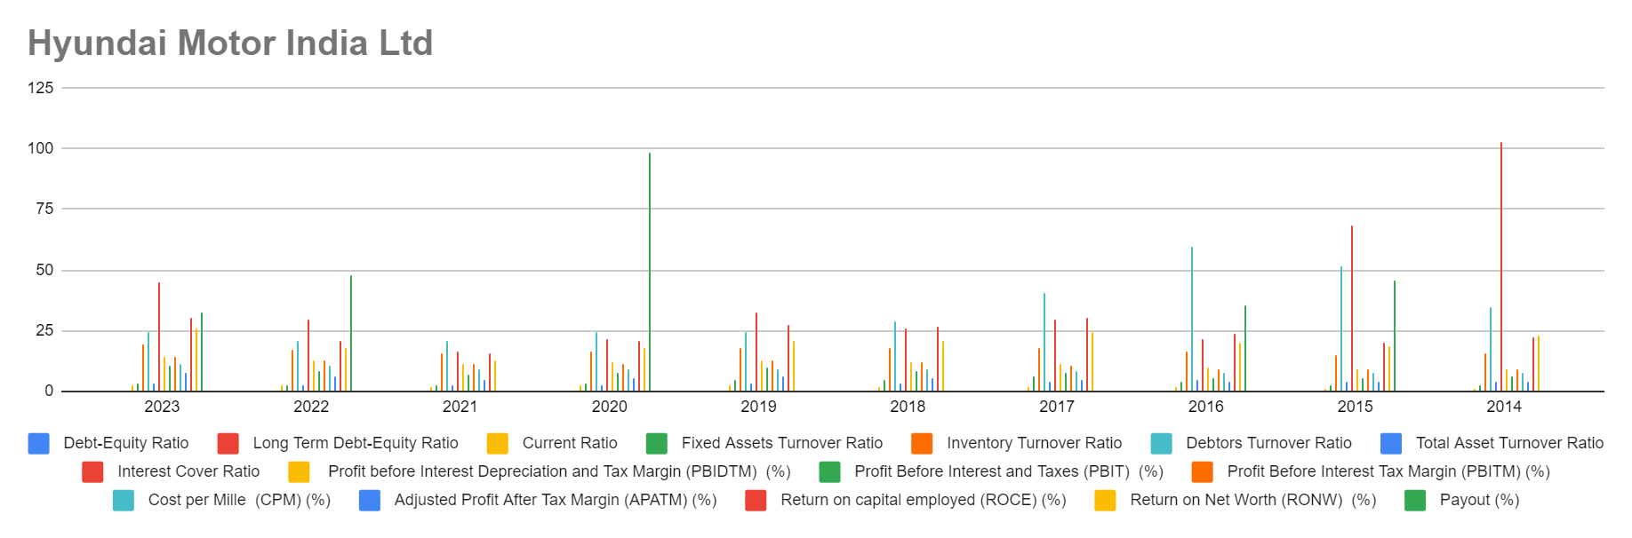

1. Debt-Equity Ratio (DER): Generally low, indicating a conservative capital structure.
2. Long Term Debt-Equity Ratio: Similar trend to DER, suggesting prudent long-term debt management.
3. Current Ratio: Fluctuates but generally above 1, indicating satisfactory liquidity levels.
4. Fixed Assets Turnover Ratio: Generally high, indicating efficient utilization of fixed assets.
5. Inventory Turnover Ratio: Generally high, suggesting efficient management of inventory.
6. Debtors Turnover Ratio: Generally high, indicating effective receivables management.
7. Total Asset Turnover Ratio: Generally high, indicating efficient asset utilization.
8. Interest Cover Ratio: Shows fluctuations but generally positive, indicating the ability to cover interest expenses with earnings.
9. Profitability Ratios: Generally positive, indicating satisfactory profitability levels.

### **8.Ford India Pvt Limited:**

